A000-Anatolia-Hittite-Alabaster Cup-Iron Smiths and Swords-1500 BCE

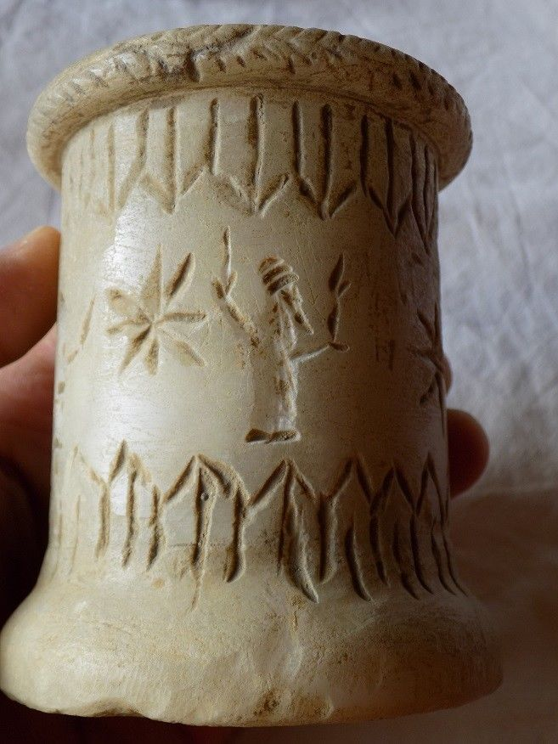

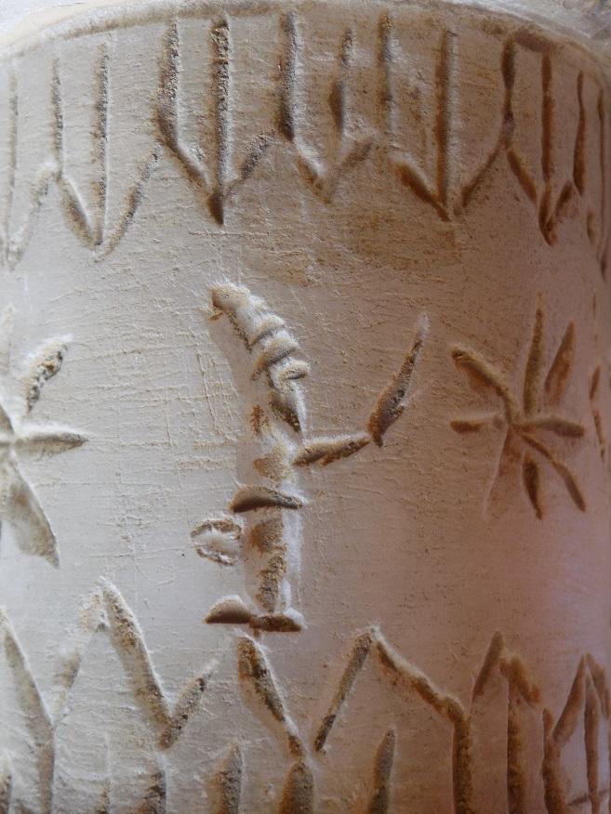 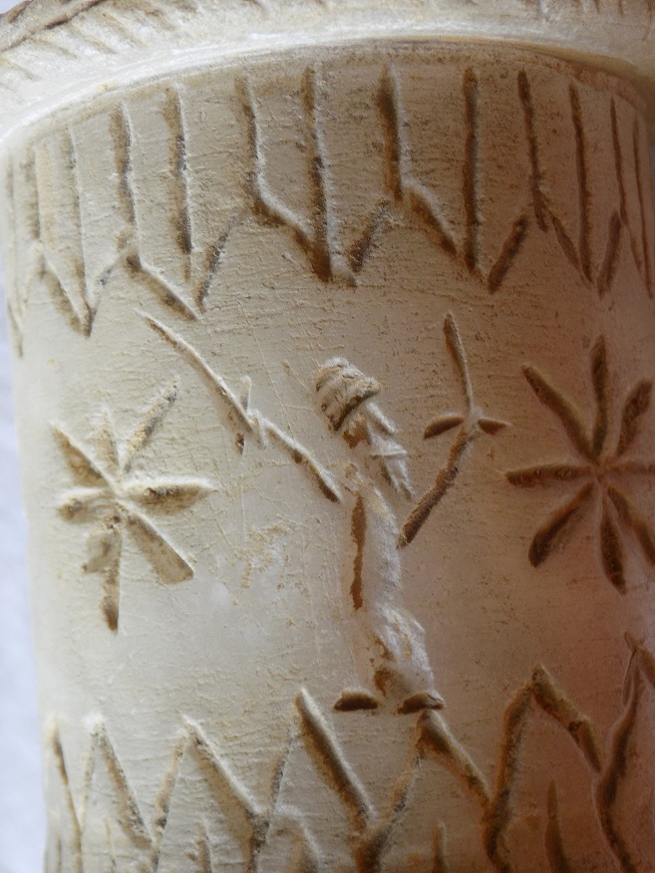 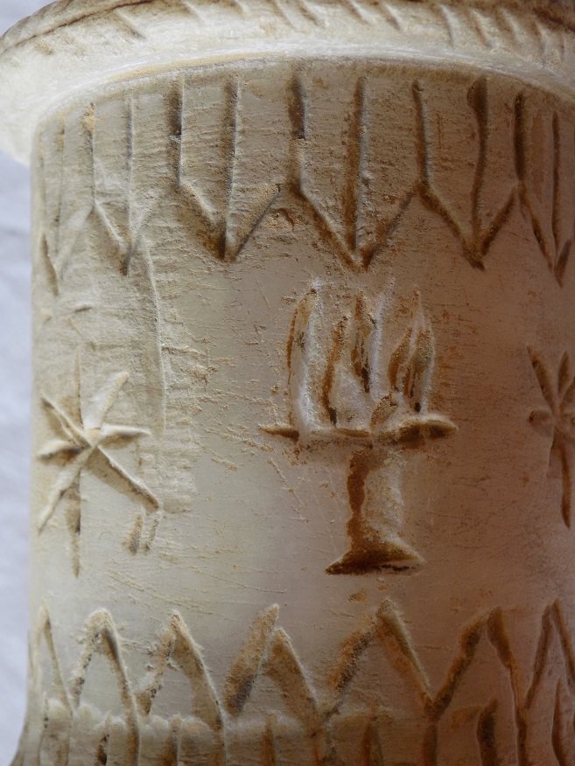 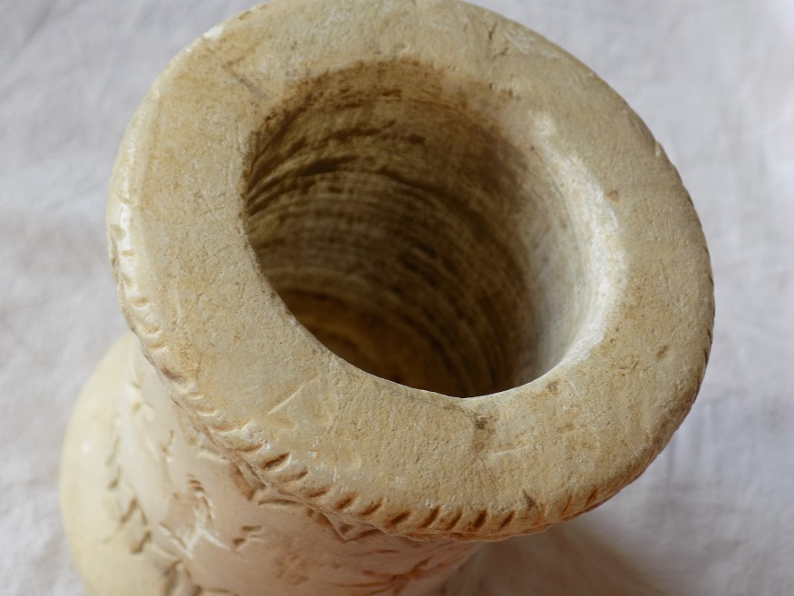

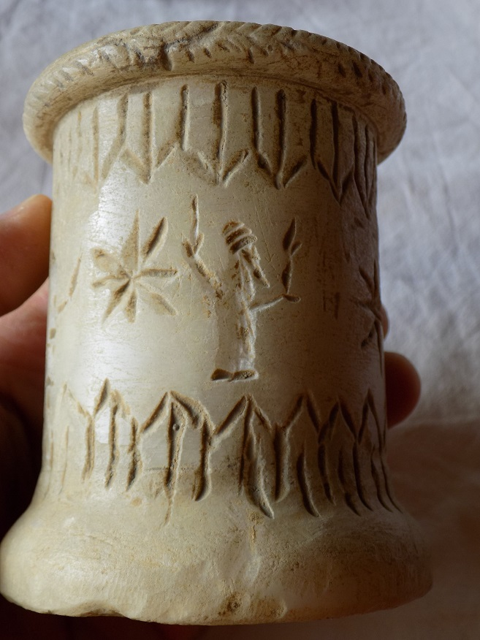



This statue of a Hittite priest-king from the Cleveland Museum of Art’s collection was carved from basalt around the year 1600 BCE. The nearly 3-foot-tall sculpture has inlaid bone eyes, a conical hat and wears a ceremonial beard. The figure probably held a staff or sword in one hand. The Hittites were among the first ancient people to use iron for tools and weapons. They spoke an Indo-European tongue—a branch of language that includes Sanskrit, Greek, Latin, Persian, German, and English.

Hittite iron metallurgy is mentioned in Old Hittite Period Cappadocian sources of the 17th-16th centuries BCE, but it is an unusual metal that was restricted to royal insignia, lances and scepters which were associated with military ritual. Middle Hittite (15th-14th century BCE) cultic use of iron objects included ceremonial axes. *litui* (curved augural staffs) and jewelry. Again the axes and litui were associated with military ritual. Then in the 14th and 13th centuries BCE manufacture of iron objects expanded as communities paid taxes in smelted iron. Objects now included anthropomorphic and zoomorphic idols, knives, daggers, swords and spearheads. Interestingly, black or meteoric iron, which known to come from the heavens, was used for the same objects as earthly iron, and there is no evidence of its being sought for any special cultic use.

Hittite processing of metals was done by smiths (LÚSIMUG) and metalworkers, LÚTIBIRA with specialized branches of these occupations headed by

Hittite 13th century economic records indicate one quarter of taxes were paid in raw metals, of which 60 percent was copper, 8 percent was tin and 13 percent was silver but gold and iron were negligible. Hittite 13th century administrative centers and temples, indicate 94 percent of copper, tin and silver assets were processed by silversmith-treasurers (LÚKU3 .DÍM) one of the most influential officials of the state administration.(Siegelová 1986: 119-20). The Hittite state was committed to metalworking.16 with finished copper, tin and silver manufactures accounting for 40% of the total in state coffers. 18

16 A. Müller-Karpe 1994, 76. 17 A. Müller-Karpe 1994, 77. 18 A. Müller-Karpe 1994, 78. 19 Siegelová 1986, 118-21.

Müller-Karpe, A. 1993: ‘Hethitische Dechsel’. IstMitt 43, 227-34. — 1994: Altanatolisches Metallhandwerk (Offa-Bücher 75) (Neumünster). — 1999: ‘Untersuchungen in Ku≥aklı 1998’. MDOG 131, 57-113. — 1999-2000: ‘Die Akropolis der hethitischen Stadt Ku≥aklı-Sarissa’. NBA 16, 91-110. –– 2000: ‘Zur Metallverarbeitung bei den Hethitern’. In Yalçın, Ü. (ed.), Anatolian Metal, vol. 1 (Der Anschnitt Beiheft 13/ Veröffentlichungen aus dem Deutschen Bergbau-Museum Bochum 92) (Bochum), 113-24. — 2005: ‘Metallbarren bei den Hethitern’. In Yalçın et al. 2005, 485-92 Müller-Karpe, H. 1980: Handbuch der Vorgeschichte, vol. 4, pt 3 (Munich)

Siegelová, J.1986. *Hethitische Verwaltungspraxis im Lichte der Wirtschafts- und Inventairdokumente,* 3 vols. Prague: Národni Muzeum.